**Computer Vision Project Report**

**Topic:**

**Emotion Detection (Real time)**

**Members:**

**Samran Elahi (16k-3819)**

**Neha Nadeem (16k-3677)**

**Abdullah Mujeeb(16k-3700)**

**Introduction**

Our project was to detect seven human emotions (0=Angry, 1=Disgust, 2=Fear, 3=Happy, 4=Sad, 5=Surprise, 6=Neutral) in real time using web camera. We were successful in making this project and got a training accuracy= 98% and a test accuracy = 57%. Our accuracy is relatively ok considering the fact that have the same accuracy as top 15th spot on kaggle.

**About**

The data provided us pixel values separated by spaces instead of complete images so we had to first remap the pixels values into a numpy array. We then trained a Convolutional Neural Network on the data. First we tested model on still images and then using OpenCV and Haar Cascade developed the Real time functionality.

**How to run the project**

1. First clone the repository
2. Open the jupyter notebook
3. Find and run the following cell first

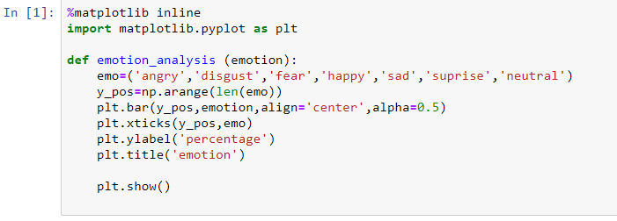

1. Next you want to do the emotional analysis on a still image run the following cell and write down the path in the img.load_image function 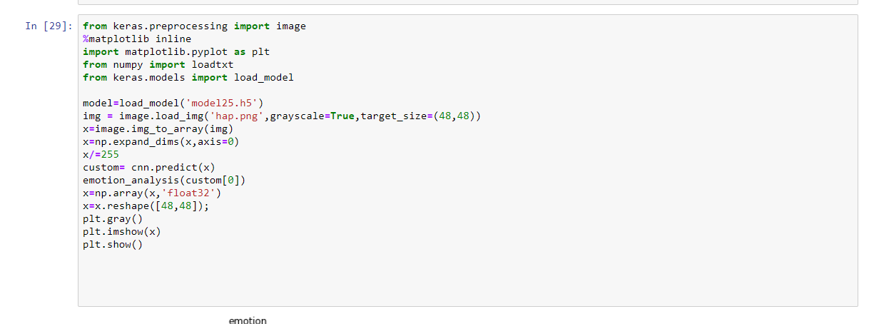
2. For real time emotional analysis by using the web cam you need to run the last block the notebook which is the following

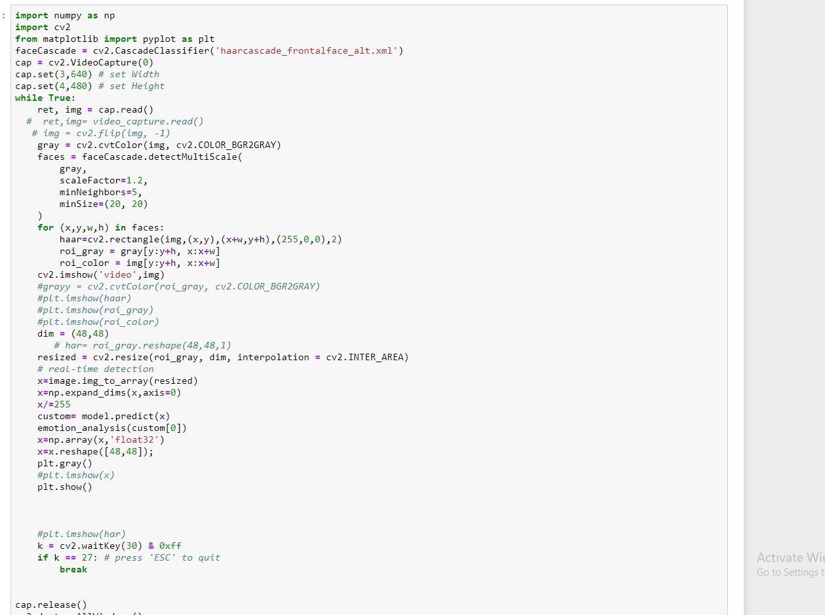

**Dependencies**

* The model25.h5 file is where I stored the weights of the CNN that we trained, so do not delete this file otherwise you would have to retrain the CNN
* I have attached a couple of images in the repository so you to play around with these and see the output of emotional analysis still images (note you can also use your own images for emotional analysis)

**Tool/Libraries**

* **Python**
* **Keras**
* **OpenCV**
* **Pandas**
* **Numpy**
* **Scikit learn**